***RPG Project*** *<Name to be determined later>*

*Ian Beard*

*ian.beard@bellevuecollege.edu*

***Scope***

I want to make a web based single player turn based RPG using HTML5 Canvas. The scope of the full project is potentially quite large. While perhaps not as massive as some notorious “90 hour RPGs,” this project could still be quite the undertaking

For the purposes of building a prototype, however, development will initially be limited to letting users play through a single battle.

***Business Narrative***

**General Specs**

- The game will be a single player turn based RPG. The prototype will mainly focus on the combat system.

- The game will use HTML5 Canvas for the visual elements. Pre-built game engines may already exist for HTML5, this will be researched early in development.

- The game will use Node.js and React (Subject to change)

- The database will use MySQL.

- The prototype will allow users to select both the player characters they want to use, and the enemies they would like to fight.

**Combat System**

Players will win after incapacitating all opponents. They will lose if all of their characters are incapacitated

Characters (playable or otherwise) have 6 main stats:

- Strength (determines physical attack damage)

- Willpower (determines strength of magical attacks and increases resistance to mental status ailments)

- Dexterity (determines accuracy of physical attacks)

- Focus (determines accuracy of magical attacks)

- Defense (reduces damage of incoming attacks and increases resistance to physical status ailments)

- Agility (reduces accuracy of incoming attacks)

Weapons will have a block rate and attack power assigned to them. Attacks will have damage values, accuracy ratings, and critical hit rates assigned to them.

Characters have 4 resources to manage during battle:

- Health (Reduced by taking damage from attacks, gained by healing. Characters are incapacitated when their health reaches 0.)

- Action Points (Characters gain a number of action points each turn, up to a certain limit. These points are spent to perform actions, like attacking or casting spells. Characters may take as many actions as they like per turn so long as they have enough points to spend <Limited to one attack per turn>.)

- Essence (Used to cast spells. Rather than a number of points being spent, Essence is accumulated by a character when they cast spells. If they continue to cast spells after they have reached their maximum amount of essence, they will take damage.)

- Tension (Represents a characters morale, measured as a percentage value. Tension is gained by scoring critical hits or from support spells, and is lost by missing, taking damage, or from certain enemy skills. High Tension increases accuracy and grants access to powerful actions, low tension lowers accuracy and prevents some actions from being performed. Tension also effects how resistant a character is to mental status ailments.)

Enemies will target characters based on their level of aggression (Aggro) towards them.

- Aggro towards each player controlled character is tracked separately by each enemy.

- Aggro towards a character is gained when they deal damage (only gained by the enemy taking damage), cast spells, or when they use abilities that explicitly state that it increase aggro.

- Aggro is lost when a character takes damage (only the aggro towards the character taking damage) or uses an ability that explicitly states that it decreases aggro.

- Players will be able to arrange their characters into a front and back battle line. Characters on the back line will gain aggro at a reduced rate, but will be unable to perform melee attacks.

***User Stories/Test Plan***

Player needs to be able to see which characters and enemies they can select at the start of the game.

Test: List of characters and list of enemies displayed on screen

Player needs to be able to select which characters/enemies they want to play with/against.

Test: Characters/enemies can be added to list of selected characters/enemies

Player needs to be able to start the game after they have made their selections.

Test: The screen displays the battle field and battle menu

Players need to be able to see all of the characters/enemies on the screen while playing.

Test: The battle starts will all selected characters/enemies present on the screen

Players need to be able to know which character/enemies turn it is at any given time.

Test: Visual indicator for who’s turn it is should be on screen

Players must be able to pause and resume the game at any time.

Test: Pause menu can be opened and closed at any time

Players must be able to do the following things on the pause screen:

- Restart the game.

Test: The battlefield is reset to it’s initial state, with all selected characters and enemies on screen

- Exit the game.

Test: The player is returned to the start screen

- View the controls

Test: The controls are displayed on screen

- View a tutorial of the game’s mechanics.

Test: The Tutorial can be opened and closed via the pause menu while playing the game

Players must be able to access a tutorial of the mechanics from the selection screen.

Test: The tutorial can be opened and closed from the select screen

Players must be able to see the health of all characters/enemies on the screen.

Test: A health bar can be seen below each character/enemy on screen

Players must be able to tell which enemies are targeting which characters.

Test: A visual indicator for enemy aggro can be seen next to each enemy

During a characters turn:

- players must be able to see and select the actions that character can perform.

Test: Available actions can be seen and selected via the battle menu

- players must be able to select an option to view the status of all of their characters.

Test: Characters can be selected from the battle menu, which displays a popup showing their current status

- Players must be able to select valid targets after selecting an action for a character to perform.

Test: Players should be able to see a visual indication of who they are targeting with their abilities

- Players must be able to continue to select actions for the active character until they have no action points left or they have no desire to perform additional actions.

Test: Performing a single action should not end the turn

- Players must be able to see the current health, action points, essence, and tension of the active character.

Test: The “resources” of the active character should be seen next to the battle menu

Players must be notified of their victory after defeating all enemies.

Test: A victory screen must be shown after winning a battle

Players must be notified of their defeat after all characters have been defeated.

Test: A defeat screen must be shown after losing a battle

Players must have an option to play again after the game ends.

Test: Players must have an option to return to the select screen after winning or losing.

***Use Case Scenarios***

|  |  |
| --- | --- |
| Player  Using Battle Menu | Check Character Stats |
| See Active Character Resources |
| See Active Character’s Available Actions |
| See Description/Cost of Available Actions |
| Select Action from List of Available Actions |
| Deselect Action Before Choosing Target |

***External Interfaces***

This system will use an external database to store information about characters and enemies. When the game is loaded, players will be provided with a list of characters and enemies to choose from that is populated by this database.

***List of Steps/Activity Diagram***

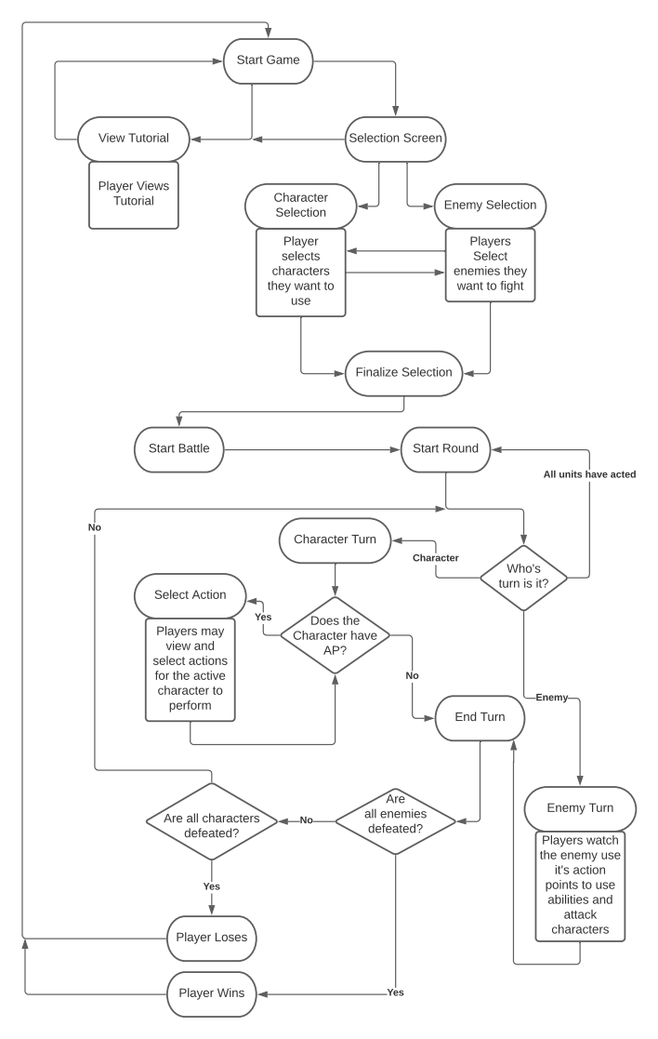

***Class Diagram***

